HOUSE PRICE PREDICTION USING MACHINE LEARNING
QSkill AI & Machine Learning Internship
Submitted By:
Kandhi Charan Yadav
B.Tech Computer Science and Engineering
SR University

Abstract:
House price prediction is an important application of Machine Learning that helps estimate property values based on housing characteristics. This project aims to develop a machine learning model that can accurately predict house prices using historical housing data. The California Housing Dataset was used for training and testing the model. A Random Forest Regressor was implemented to improve prediction accuracy. The model achieved an R² Score of 80.62% and successfully predicted house prices.
Introduction:
House prices are influenced by multiple factors such as location, income level, number of rooms, population, and geographical coordinates. Predicting house prices manually can be difficult because of the complex relationships among these factors.
Machine Learning provides an efficient solution by learning patterns from historical housing data and generating accurate price predictions. In this project, a Random Forest Regressor model was used to predict house prices using the California Housing Dataset.
Objective:
The main objectives of this project are:
• To predict house prices using Machine Learning.
• To analyze housing data and identify important features.
• To train a regression model for accurate prediction.
• To evaluate model performance using standard regression metrics.
Dataset Description:
The California Housing Dataset contains housing information collected from different districts of California.
Dataset Statistics
• Total Records: 20,640
• Total Features: 8
• Target Variable: House Price

The dataset consists of the following features:
- Median Income
- House Age
- Average Rooms
- Average Bedrooms
- Population
- Average Occupancy
- Latitude
- Longitude
Target Variable:
• House Price
Methodology:
The project follows the following steps:
Step 1: Data Collection
The California Housing Dataset was loaded using Scikit-learn.
Step 2: Data Exploration
The dataset structure and feature information were analyzed.
Step 3: Data Preprocessing
• Checked dataset quality.
• Selected input and output features.
• Prepared data for model training.
Step 4: Train-Test Split
The dataset was divided into:
• Training Data: 80%
• Testing Data: 20%
Step 5: Model Training
A Random Forest Regressor model was trained using the processed dataset.
Step 6: Prediction
The trained model was used to predict house prices for testing data.

Step 7: Model Evaluation
The trained model was evaluated using:
• Mean Squared Error (MSE)
• R² Score
Tools and Technologies Used:
• Python
• Pandas
• NumPy
• Scikit-learn
• Matplotlib
• VS Code
Implementation:
The implementation involved:
- Loading the dataset.
- Creating a DataFrame.
- Splitting the dataset into training and testing sets.
- Training the Random Forest Regressor.
- Predicting house prices.
- Evaluating model performance.
- Visualizing actual and predicted house prices.
Results:
Model Performance:
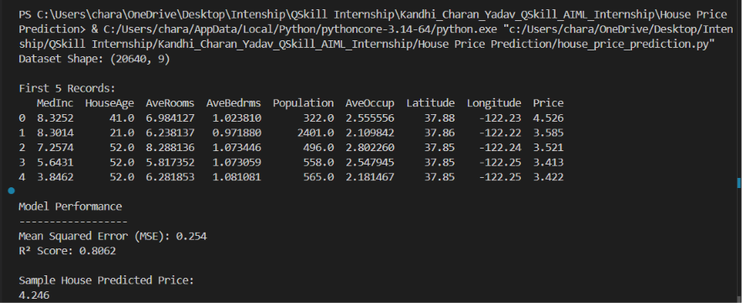

Actual vs Predicted House Prices:
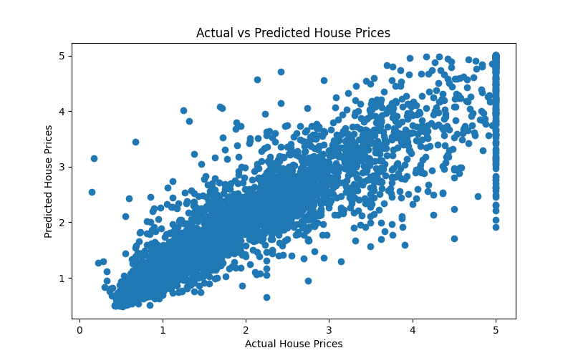

Performance Metrics:
• Mean Squared Error (MSE): 0.254
• R² Score: 80.62%
Sample Prediction:
Predicted House Price: 4.246
Advantages:
• High prediction accuracy.
• Handles large datasets efficiently.
• Captures complex relationships between features.
• Useful for real-world price estimation.
Applications:
• Real Estate Price Prediction.
• Property Valuation Systems.
• Housing Market Analysis.
• Investment Decision Support.
• Smart Real Estate Platforms.

Conclusion:
The House Price Prediction project successfully predicted house prices using Machine Learning techniques. The Random Forest Regressor achieved an R² Score of 80.62% with a Mean Squared Error of 0.254. The project demonstrates the effectiveness of Machine Learning in solving real-world regression problems and providing accurate predictions.
References:
- California Housing Dataset.
- Scikit-learn Documentation.
- Python Documentation.
- Pandas Documentation.
- Machine Learning with Python Resources.

